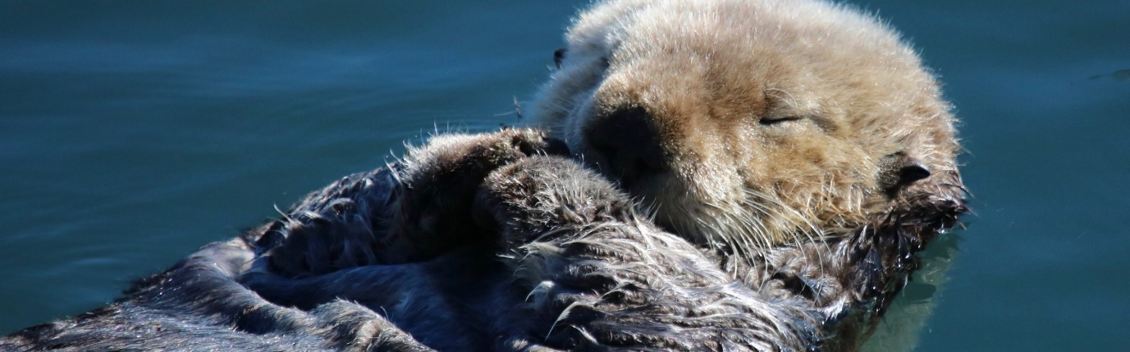Dealing with Loneliness
In wellbeing assembly this week, we learnt about sea otters. Sea otters prefer to live in groups. The hold hands to prevent them from floating away from the group in the vast ocean when they sleep. They are sociable creatures.
Humans are sociable too. This means we need to talk and engage in activities with other people: it makes us feel happy and safe. It is perfectly normal to spend time on your own, we are all different and want different amounts of social interaction. If you don’t have people to talk to, you can feel lonely and isolated. Feeling left out can have an impact on your self-esteem and confidence. Some people think that being lonely is being on your own but it is possible to feel lonely in a crowd if you don’t feel valued or heard.
When you see someone who is being left out, show them kindness. We all have the power to make a difference in someone else’s life.
Here are some things that we can do:
- Look out for people who are on their own at break time.
- Allow everyone to join in with your games.
- Sit down next to someone who is eating lunch on their own.
- Carry out acts of kindness for someone who look lonely.
- Make sure that you check on elderly relatives, especially if the live on their own.
- Be a good listener.

