_________________________________________________________________________

Sports Premium Funding

What is the Sport Premium?
In March 2013 the government announced that it was to provide additional funding to improve provision of Physical Education (PE) and sport in primary schools in England: The Primary PE and Sport Premium. This funding, provided jointly by the Departments for Education, Health and Culture, Media and Sport, is allocated to primary schools.
The funding is ring-fenced and can only be spent on provision of PE and sport in schools. This year we have received additional funding for sports amounting £16,655
Schools must use the funding to make additional and sustainable improvements to the quality of PE and sport they offer. This means that we need to use the Primary PE and Sport Premium to:
- develop or add to the PE and sport activities that our school already offers.
- build capacity and capability within the school to ensure that improvements made now will benefit pupils joining the school in future years.

Objectives of the Sports Premium

Key objectives include:
- Engaging pupils in regular physical activity and promoting healthy lifestyles
- Raising the profile of PE and sport across the school
- Improving staff skills and confidence in teaching PE
- Developing the sports curriculum
- Increasing participation in competitive sport and inter-house competitions

How We Use the Sport Premium
We use the Sports Premium to make lasting improvements to our PE and sport provision by:
- Expanding our PE and sports offerings
- Investing in equipment and facilities
- Developing rewards and successes
- Providing staff training and development
- Use coaching to enhance enjoyment
- Running after-school clubs
- Embedding physical activity throughout the school day
- Developing the swimming provisions.

Impact on Pupils
The Sports Premium has a positive and wide-reaching impact on our pupils by:
- Building resilience and teamwork skills through clubs and teams
- Enhancing physical fitness and wellbeing
- Helping pupils feel valued and included
- Boosting confidence in children who may otherwise disengage from PE
- Providing opportunities for engagement with varied sports and skills.
- Improving interest in sports which has impacted on engagement in lessons
- Improving accessibily to extra curricula sports activities has increased engagement in sports clubs and attendance to these
- Increasing pupils attainment in PE
How improvements will be sustained

- Develop sports leaders to enhance inter-house sports and play in school.
- Continually developing further access to sports both in school and through extra curricula activities
- Further develop the curriculum through training and resourcing.
- Continually developing regular fitness activities throughout the timetable
- Develop external sports engagement through competitions.
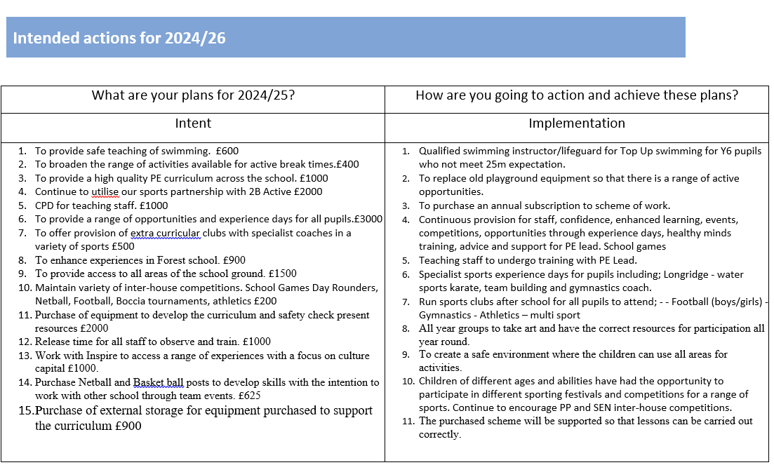
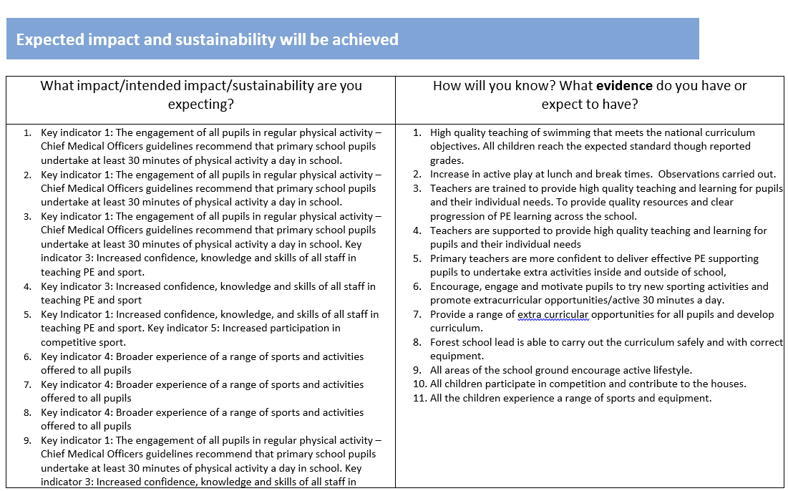

Denham Village School Spend Summary 2024-2025
 | Cost
Key indicator 1: The engagement of all pupils in regular physical activity
Internal school based extracurricular opportunities | £1745
Key indicator 2: The profile of PE and sport being raised across the school as a tool for whole school improvement
Interschool Training and resource development | £2000
Internal Sports competitions | £725
Equipment and resources | £900
Active playtimes | £100
Key indicator 3: Increased confidence, knowledge and skills of all staff in teaching PE and sport
External Coaches supporting confidence and competence. | £2850
Online training and resource development | £2900
Membership to planning and training | £875
Education Platform resources | £245
External Training courses | £1125
Swimming CPD | £600
Internal Learning and Development | £1000
Key indicator 4: Broader experience of a range of sports and activities offered to all pupils
Key indicator 5: Increased participation in competitive sport
Transport Cost | £500
Total Spend | £16,660

