________________________________________
Whole School Healthy Eating Policy
Last Updated: January 2026
Update Required: January 2028

INTRODUCTION

At Denham Village School, we are dedicated to helping your child make sensible food choices as part of maintaining a healthy lifestyle.
Government strategy outlines an expectation for all schools:
To promote a culture of healthy eating the government now expects all schools, in consultation with parents, pupil and staff, to adopt whole school food policies. In particular, schools will be expected to develop healthy packed lunch policies so that those not yet taking up school lunches are also eating healthier.
Our Whole School Food Policy (incorporating Packed lunch, Healthy Snack and Drinks in school policies) has been developed in line with key government guidance on healthy eating and the school day, and forms part of our broader commitment to promoting a whole-school approach to nutrition and wellbeing.
Government guidance emphasizes that all schools should:
- Promote a culture of healthy eating.
- Work in consultation with parents, pupils, and staff to adopt whole-school food policies.
- Develop healthy packed lunch policies to ensure that pupils not taking school-provided meals are also making healthier choices.
This policy applies to all pupils, staff, and parents providing packed lunches or other foods to be consumed on school premises or during school trips during normal school hours.
Staff will be expected to model healthy lunch, snack and beverage choices whilst in school.

AIMS

This policy supports our commitment to helping pupils make healthy food choices, develop good eating habits, and maintain the energy they need for learning and play. It aligns with the School Food Standards and our Healthy Schools ethos.
- To ensure the contents of lunchboxes reflect the requirements of schools to meet minimum food and nutrition standards for school meals
- To make a positive contribution to children’s health by encouraging healthy eating habits in childhood that can influence health and well-being in later life
- To take a proactive approach to promoting healthy eating
- To give clear guidance to parents/carers, pupils, governors, and staff on providing a healthy packed lunch and/ or snacks
- To support parents by providing ideas for healthy packed lunches, snacks and healthy hydration
- To equip pupils with the skills, knowledge, and understanding to enable them to make informed healthy lifestyle choices based on their nutritional understanding
- To ensure that all children have a healthy and nutritious midday meal that sustains and prepares them for their afternoon learning

LINKS TO OTHER SCHOOL POLICIES
- Wraparound care food policy (Breakfast Club and Afterschool clubs)
- Curriculum policies through which healthy eating messages are to be delivered e.g. Science, Design & Technology, PSHE.
- Integration of the PhunkyFoods Programme across the whole school community; including the involvement of the PhunkyFoods Ambassador programme.
- Teaching and Learning, particularly how being well nourished and hydrated can assist with learning, and ways in which this is encouraged within school. Linking to emotional wellbeing.
- Health and Safety, how basic food hygiene is followed within school, including cooking within the classroom environment, and the storage of food.
PROVISION OF PACKED LUNCHES

Food contained in a packed lunch
Parents/carers of pupils who do not have school meals are expected to provide their children with packed lunches that are consistent with the nutritional standards based on the EatWell Guide and the School Food Trust guidelines.

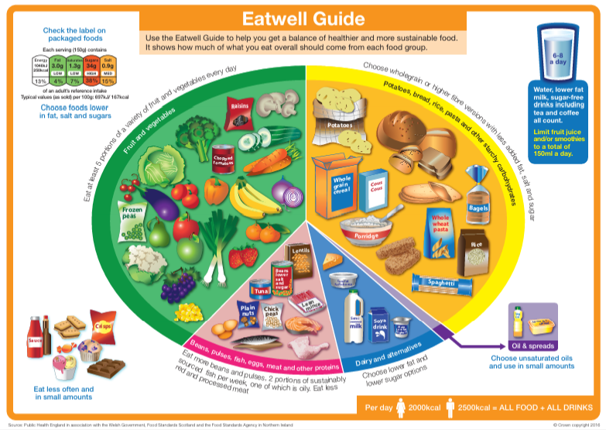

The recommended contents of a healthy lunch box are:
- Fruit and vegetables; at least two portions of fruit or vegetables every day (a portion is the amount your child can fit into the palm of their hand). This could be fresh, dried, or tinned.
- Carbohydrate; a starchy food every day, such as bread, pasta, rice, couscous, noodles, potatoes, chapatis/roti, plain crackers, breadsticks, rice cakes or other cereal
- Protein; meat, fish, egg, or other source of non-dairy protein such as lentils, kidney beans, chickpeas, hummus, dhal, falafel
- Oily fish; tinned or fresh mackerel, sardines, or salmon should be included at least once every three weeks
- Dairy; every day, such as milk, cheese, yoghurt, fromage frais or calcium fortified soya products - reduced fat if possible
- A bottle of water; It is recognised that the concentration and behaviour of children improve when children drink water throughout the day. Dehydration can give children headaches and make them tired. Therefore, we encourage children to bring in water bottles daily.
- Other drinks semi-skimmed/skimmed milk, milk-based or yoghurt-based drinks
- Dessert/pudding; such as a small cake, biscuit, cereal bar, fruit loaf/bun, OR scotch pancake as part of a balanced meal. Take care to check packaged items as many may look healthy but can have high levels of sugar and fat. Look for those with 100 calories or less per portion and only include one a day for lunch.

EXCLUDED ITEMS

Packed Lunches should not include:

- Sweets/confectionery such as chocolate bars, chocolate-coated cereal bars, processed fruit bars and sweets. Cakes and biscuits but in moderation and we encourage your child to eat these only as part of a balanced meal
- Juice cartons, bottle of fruit drinks, fizzy or sugary drinks, or energy drinks
- Snacks such as crisps or cheddars - instead, include seeds, vegetables and fruit (with no added salt, sugar or fat). Breadsticks served with fruit, vegetables or dairy food are also a good choice.
- A standard-sized bag of crisps of around 25g will be allowed as an accompaniment on Fridays only.
- Nuts, or items containing nuts, to include: Peanut butter, nutella, almond slice, bombay mix.
Some children are allergic to nuts and they can cause a severe reaction even when in other pupils’ lunches.
Provision for Packed Lunches
- School will provide dining room facilities where pupils can eat their lunches.
- School will ensure that fresh drinking water is readily available at all times.
- We ask that parents/carers and pupils:
  - provide a packed lunch container where food items can be stored securely and appropriately until the lunchtime period;
  - bring packed lunches in reusable plastic containers, rather than disposing of plastic bags and bottles.
  - Fridge space for packed lunches is not available, so it is advisable to bring packed lunches in insulated bags with an ice pack to keep the food fresh.
Waste and disposal
The school will, within reason, send any uneaten packed lunch food items back home. The rationale for this is that parents can also monitor what their child has consumed during the day and then raise any concerns over their child’s food intake with the school.

DRINKS IN SCHOOL

- Water is the best choice for regular hydration during the school day.
- Drinks high in sugar, artificial sweeteners are not permitted.
- Drinks containing caffeine are not permitted for pupils.
- Milk and certain other drinks are allowed at specific times to support nutrition and inclusion.

Permitted Drinks
- Plain still water – available throughout the day.
- Semi-skimmed milk (or non-dairy alternative if required for allergies or dietary needs) – provided through the School Milk Scheme for eligible pupils.
- School-approved drinks for medical or cultural reasons, agreed in advance with the Headteacher or SENCo.

Times for Drinking
- Classroom – Pupils may drink water throughout lessons, except during specific activities where it would be unsafe or disruptive (e.g., science experiments, ICT sessions).
- Break and lunch – Pupils are encouraged to drink water or milk.
- After PE – Pupils should drink water to rehydrate.

Drinks Not Permitted
- Fizzy drinks, energy drinks, or sports drinks
- Squash, diluted juice, cordials (unless sugar-free and approved for a one-off special event)
- Fruit juices (except when medical needs are being met)

PROVISION OF SNACKS FOR BREAKTIME

- Snacks should contribute positively to children’s nutritional needs.
- Foods high in sugar, fat, or salt are not permitted for snack times.
- The school promotes fruit, vegetables, and other wholesome options as the default snack choices.

Allowed Snacks
- Fresh fruit and vegetables – e.g., apples, bananas, berries, grapes, carrots, cucumber sticks.
- Dried fruit – e.g., raisins, apricots (served in small portions (30g max) and ideally with a main meal to protect teeth).
- School-provided snacks – Pupils in Reception, Year 1, and Year 2 will receive a daily piece of fruit or vegetable through the School Fruit and Vegetable Scheme.
Snacks Not Permitted
- Sweets, chocolate bars, chocolate-covered biscuits.
- Crisps, flavoured popcorn, or other salty snacks.
- Pastries, cakes, or high-sugar cereal bars.
- Sugary spreads or dips (e.g. chocolate spread).
Times for Eating Snacks
- Morning break is the designated snack time.
- Snacks should not be eaten in class unless agreed for medical reasons.
- All food should be consumed in designated eating areas or playgrounds to maintain cleanliness and safety.

SPECIAL DIETS & ALLERGIES

Special Diets and Allergies
The school recognises that some pupils with medical or dietary needs (e.g. allergies, diabetes) may require special diets that do not follow the National Food Standards exactly.
In this case, parents/carers are asked to inform the school, ensuring individual arrangements are agreed, and that their child’s snack and lunchbox as healthy as possible. For this reason, pupils are not permitted to swap food items.
Special Considerations
- Any birthday sweets are to be given on playground by the child’s family so that parents can monitor what their child is eating. No nut products to be included in the birthday treat.
- Very occasionally, the PTA may organise a cake sale for charity and purchase cakes to raise money for a good cause. Or the PTA may reward competition with food rewards.
- The use of sweets for rewards is kept to a minimum. Instead, children are rewarded with stickers, praise, visits to other classes or the head teacher to celebrate their work and phone calls home to parents.
- Occassional school projects that may take place at the end of a term.
CURRICULUM, TEACHING AND LEARNING

Whilst we fully respect individual food choices and understand that there are many different needs and tastes, we want to work with parents to educate children about healthy diet choices so that our children, through understanding a balanced diet, will develop a greater appreciation of a healthy lifestyle. The formal curriculum develops pupils’ knowledge of healthy eating predominantly through PSHE, Science and Design Technology lessons.
PROVISION AT BREAKFAST CLUB AND AFTERSCHOOL CLUB

Wraparound care, including Breakfast and After-School Clubs, forms an extension of the school day and follows the same principles set out in our Whole School Food Policy. These clubs aim to provide nutritious food and drink that support pupils’ concentration, wellbeing, and energy levels throughout the day.
Provision of Food and Drink
- Breakfast options will include items such as wholegrain cereals, toast, fruit, yoghurt, and milk or water, while avoiding foods high in sugar or that are highly processed.
- After-school sessions will provide balanced snacks such as fruit, vegetable sticks, wholegrain crackers, oatcakes, cheese, breadsticks, and yoghurt.
- Sugary drinks, confectionery, and fried or high-fat snacks are not permitted.
- Fresh drinking water will always be available.

Expectations and Practice

- Staff will promote and model healthy eating habits at all times.
- All dietary, cultural, and allergy requirements will be appropriately managed.
- Parents and carers are encouraged to support the school’s approach by avoiding sending in high-sugar or processed snacks for wraparound sessions or clubs attended.
- These standards ensure that afterschool provision continues to promote a consistent culture of healthy eating and supports pupils in developing lifelong positive food choices.

DISSEMINATION OF THE POLICY

The school will write to all new and existing parents/carers to inform them of the policy via the school newsletter.
The policy will be available on the school’s website and will be incorporated into the school assemblies and policies.
The school will use opportunities such as parents' evenings and Healthy Living events to promote this policy as part of a whole school approach to healthier eating.
All school staff, including teaching and catering staff, will be informed of this policy and will support its implementation.

MONITORING AND EVALUATION

To promote healthy eating, class teachers, teaching assistants, learning mentors, and lunchtime supervisors will regularly monitor the content of packed lunches and snacks brought into school.
Parents and pupils who do not adhere to the Packed Lunch Policy will receive a leaflet in the packed lunch informing them of the Policy. If a child regularly brings a packed lunch that does not conform to the policy, then the school will contact the parents to discuss this.

If a packed lunch contains items that don’t meet our policy, the child will be reminded of the schools healthy eating approach and a healthy alternative provided.
Please note: pupils with special diets will be given due consideration.
Policy review
- This policy will be reviewed as part of the school’s agreed policy review process.
- In addition, any major legislative or governmental changes regarding school food may lead to this policy being amended.

Further Guidance:
https://www.phunkyfoods.co.uk/parent/a-healthy-lunch-parents-information/
https://www.phunkyfoods.co.uk/parent/drain-your-drinks-parents-information/
https://www.phunkyfoods.co.uk/parent/snack-attack-parent-information/
https://www.phunkyfoods.co.uk/parent/strive-for-5-parents-information/

https://www.nhs.uk/healthier-families/recipes/healthier-lunchboxes/
https://www.nhs.uk/live-well/eat-well/food-guidelines-and-food-labels/water-drinks-nutrition/
https://www.nhs.uk/healthier-families/food-facts/healthier-snacks/



