______________________________________________________
Uniform Policy
Date: May 2026
Review date: May 2027

Aims
This policy aims to:
- Set out our approach to requiring a uniform that is of reasonable cost and offers the best value for money for parents and carers
- Explain how we will avoid discrimination in line with our legal duties under the Equality Act 2010
- Clarify our expectations for school uniform

Introduction
It is our school policy that all children wear school uniform when attending school, or when participating in school-organised events outside normal school hours. We ask children to wear their shirts tucked into their skirts or trousers and to take pride in their personal appearance. And the correct uniform worn at school, at all times.
Some items of uniform can be bought from our school uniform supplier, whilst others are easily available, at very competitive prices, at local shops including supermarkets. A complete list of the items needed for school uniform including those for Physical Education, is provided in the section below: School uniform list.
In this section we have clearly stated which items are branded and only available through our uniform supplier and which items you are able to purchase from local shops and supermarkets.

Aims and Objectives
Our policy on school uniform is based on the belief that school uniform:
• promotes a sense of pride in our school;
• helps to create a sense of community and belonging towards the school;
• identifies the children with the school;
• supports our commitment to inclusion;
• is regarded as suitable wear for school and good value for money by most parents;
• is practical, smart and designed with health and Safety in mind

Jewellery
We ask that no jewellery be worn at school other than discreet gold or silver studs (no more than one per ear). Studs must be removed or covered with a plaster during PE. Children will be asked to remove jewellery that does not respect the Uniform Policy.
A watch may be worn however smart watches are not allowed and we encourage children to wear an analogue wristwatch. Watches must be removed during PE activities.
Small items of jewellery will be permitted for religious reasons provided safe provision can be made during sporting activities. Please discuss this with the class teacher and the Headteacher.
Wherever possible children are required to remove any jewellery items during PE lessons to prevent them from causing injury. Please note: Teachers are not permitted to remove earrings for pupils.
Hair:
The school does not permit children to have ‘extreme’ haircuts or styles that could serve as a distraction to other children. We reserve the right to contact the parents if children come into school with an ‘extreme’ hair style.
All children with hair longer than shoulder length or that falls over the eyes must have it tied back at all times.
Hair should be secured with black or red ties or plain scrunchies. No clips, bands or headbands of any other colour are permitted. School-sized ribbons can be worn but not large scrunchies or bows with decorative embellishment or textured fabric. Children will be asked to remove them if they are worn.
. Religious Headwear: For students who wish to wear a headscarf or Patka as part of religious dress, it should be plain black, red or dark grey.
Footwear
We all understand the importance for children to grow into healthy adults; and encourage movement and activity. We believe that it is dangerous for children to wear shoes that have platform soles, high heels or slip on ballet pumps, so we do not allow children to wear such shoes in our school.
For health and safety reasons all children are required to wear plain black shoes (no boots are allowed).
Children must wear school shoes throughout the whole school day and trainers on days when PE is taking place.
The role of parents
We ask all parents who send their children to our school to support the school uniform policy. We believe that one of the responsibilities of parents is to ensure that their child has the correct uniform and PE kit, and that it is clean, in good repair and that the child’s name is written on all items.
If a parent has difficulties for any reason with fulfilling this request, they are asked to speak confidentially to a senior member of staff to discuss the issues. Parents should be assured that we will do all we can to help. Children who arrive at school wearing non-school uniform clothing may be loaned an appropriate item from our welfare stock to wear for that day. Parents may be contacted to discuss the matter if incorrect uniform becomes a concern
The school welcomes children from all backgrounds and faith communities. If there are serious reasons, for example on religious grounds, why parents want their child to wear clothes that differ from the school uniform, the school will look sympathetically at such requests. Any requests must be discussed with the Headteacher.
The school has a large selection of pre-owned uniform for those parents who require it. Items can be purchased by contacting the school office.

The Role of the Staff
Staff will closely monitor pupils to make sure they are in correct uniform. They will give any pupils and families breaching the uniform policy the opportunity to comply, but will follow up with the headteacher if the situation doesn’t improve.
- Ongoing breaches of our uniform policy will be dealt with by the school behaviour policy.
- In cases where it is suspected that financial hardship has resulted in a pupil not complying with this uniform policy, staff will take a mindful and considerate approach to resolving the situation.

The Role of Governors
The governing body supports the headteacher in implementing the school uniform policy. It considers all representations from parents regarding the uniform policy and liaises with the headteacher to ensure that the policy is implemented fairly and with sensitivity.
It is the governors’ responsibility to ensure that the school uniform meets all regulations concerning equal opportunities.
Governors ensure that the school uniform policy helps children to dress sensibly, in clothing that is hardwearing, safe and practical. Monitoring and review
The governing body monitors and reviews the school uniform policy through its committee work by:
- Seeking the views of parents, to ensure that they agree with and support the policy;
- Considering, with the Headteacher, any requests from parents for individual children to have special dispensation with regard to school uniform;
- Headteacher to report to the governors on the way the school uniform policy is implemented.

Our school’s legal duties under the Equality Act 2010
The Equality Act 2010 prohibits discrimination against an individual based on the protected characteristics, which include sex, race, religion or belief, and gender reassignment.
To avoid discrimination, our school will:
- Avoid listing uniform items based on sex, to give all pupils the opportunity to wear the uniform they feel most comfortable in or that most reflects their self-identified gender
- Make sure that our uniform costs the same for all pupils
- Allow all pupils to have long hair (though we reserve the right to ask for this to be tied back)
- Allow all pupils to style their hair in the way that is appropriate for school yet makes them feel most comfortable
- Allow pupils to wear headscarves and other religious or cultural symbols
- Allow for adaptations to our policy on the grounds of equality by asking pupils or their parents to get in touch with [Mrs Sharma 01895832768], who can answer questions about the policy and respond to any requests.

Limiting the cost of school uniform
Our school has a duty to make sure that the uniform we require is affordable, in line with statutory guidance from the Department for Education on the cost of school uniform.
We understand that items with distinctive characteristics (such as branded items, or items that have to have a school logo or a unique fabric/colour/design) cannot be purchased from a wide range of retailers and that requiring many such items limits parents’ ability to ‘shop around’ for a low price.
We will make sure our uniform:
- Is available at a reasonable cost
- Provides the best value for money for parents/carers
We will do this by:
- Carefully considering whether any items with distinctive characteristics are necessary
- Keeping the number of optional branded items to a minimum, so that the school’s uniform can act as a social leveler
- Limiting any items with distinctive characteristics to jumpers, polo shirts, t-shirts and by sourcing items with distinctive characteristics to low-cost or long-lasting items
- Considering cheaper alternatives to school-branded items, such as logos that can be ironed on, as long as this doesn’t compromise quality and durability
- Avoiding different uniform requirements for different year/class
- Avoiding different uniform requirements for extra-curricular activities with the exception of PE
- Considering alternative methods for signaling differences in groups for interschool competitions, such as creating posters or labels
- Making sure that arrangements are in place for parents to acquire second-hand uniform items
- Avoiding frequent changes to uniform specifications and minimising the financial impact on parents of any changes
- Consulting with parents and pupils on any proposed significant changes to the uniform policy and carefully considering any complaints about the policy

Expectations for school uniform
Our school’s uniform
Branded items are available from our supplier ‘My Clothing’ https://myclothing.com/collections/denham-village-school-14337 We review pricing on an annual basis to ensure that uniform costs for branded items are competitive and also have pre-owned uniform available for parents both branded and non-branded.
Where to purchase it
- Branded Items
  - Branded items are available from our supplier ‘My Clothing’. Pricing is reviewed on an annual basis to ensure that uniform costs for branded items are competitive. The link is on the school website.
- Non Branded Items
  - Non Branded items are available from a wide variety of retailers including most supermarkets.
- Pre-owned Uniform
  - Can be requested at the school office via phone or email.

Everyday Forest School
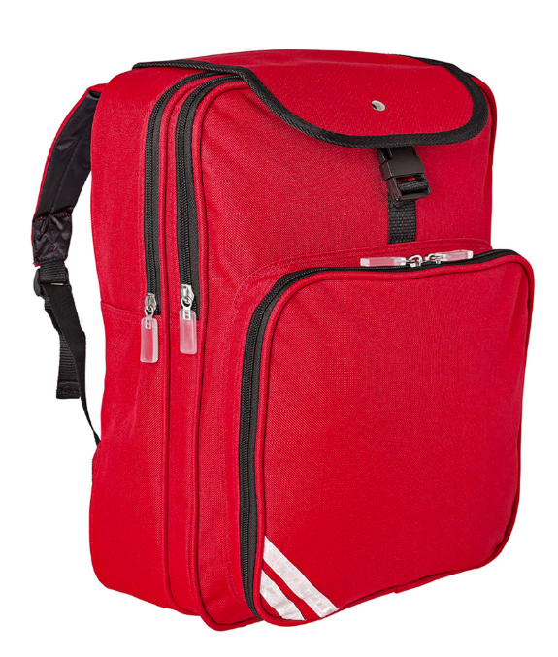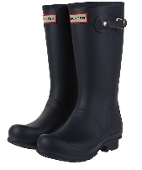
Wellington Boots
Purchase From School Purchase from any shop/supermarket

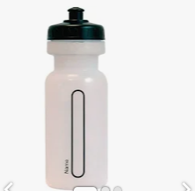
Named Water bottle
Purchase from any shop/supermarket

KS2 children (Optional for Year 1 and 2)
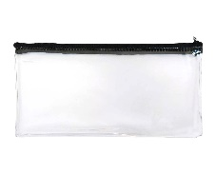
Small pencil Case, Glue stick, HB pencil,15cm ruler, Rubber, Handwriting pen (Blue) No biro pens. 6 Colouring pencils.

Uniform Purchases
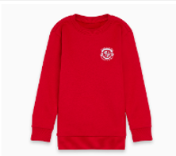or 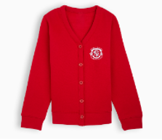
School Jumper or Cardigan with Logo. Purchase from ‘My Clothing’
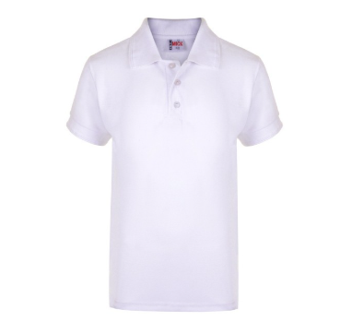
White Collared Polo Shirt . Purchase from any shop/supermarket
Autumn, Winter, Spring & cold days  Can be worn all year. | Summer Term & Warm days  No Summer Uniform After Autumn Half Term.
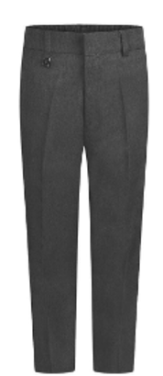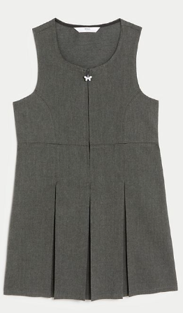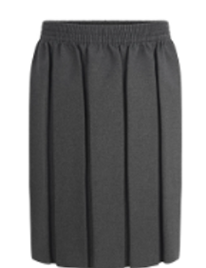  Smart Grey Trousers, Skirt or Pinafore Dress.  Purchase from any shop/supermarket. | 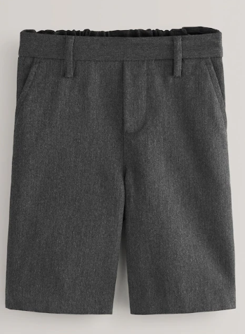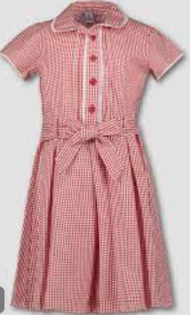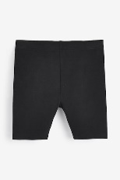  Smart Grey shorts or red checked dress with shorts (Black lycra shorter than hem) These are optional.  Purchase from any shop/supermarket
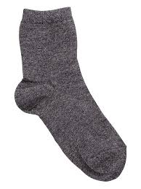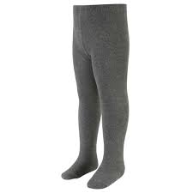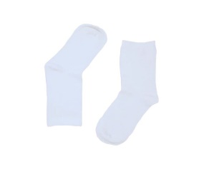
Grey or White Socks or Grey Tights
Purchase from any shop/supermarket

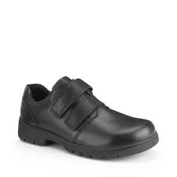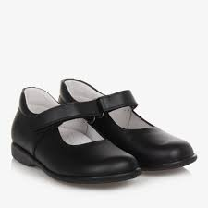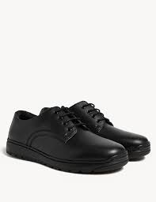
Sturdy, Black School Shoes
Purchase from any shop/supermarket

PE KIT
This is to be worn to school on timetabled PE days.
Children must wear the fleece to school on PE days.
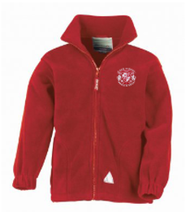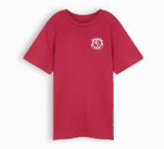
Red Fleece with Logo Red T-Shirt with Logo. Purchase From ‘My Clothing’
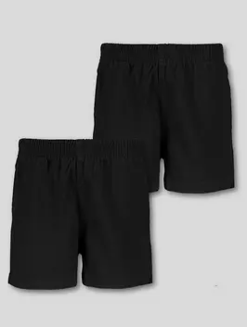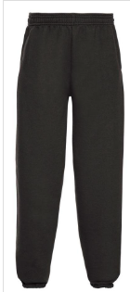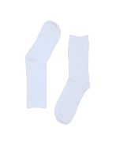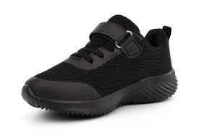
Black Shorts or Joggers Grey or White Socks Black Trainers

Purchase from any shop/supermarket
Governors
The governing board will review this policy and make sure that it:
- Is appropriate for our school’s context
- Is implemented fairly across the school
- Takes into account the views of parents and pupils
- Offers a uniform that is appropriate, practical and safe for all pupils
The board will also make sure that the school’s uniform supplier arrangements give the highest priority to cost and value for money, for example by avoiding single supplier contracts and by re-tendering contracts at least every 5 years.

Monitoring arrangements
This policy will be reviewed every three years by the head teacher.

Links to other policies
This policy is linked to our:
- Behaviour policy
- Equality information and objectives statement
- Anti-bullying policy
- Complaints policy

