Denham Village School

Meet the Teacher
Birch Class Year 1 and Year 2

September 2026



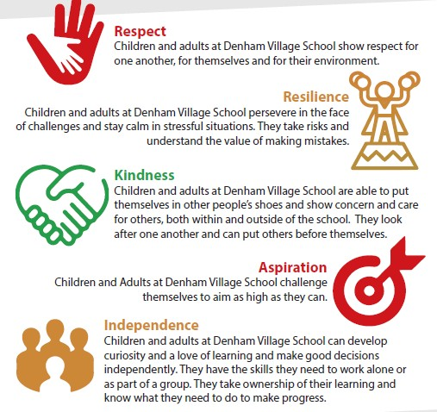
Our Values
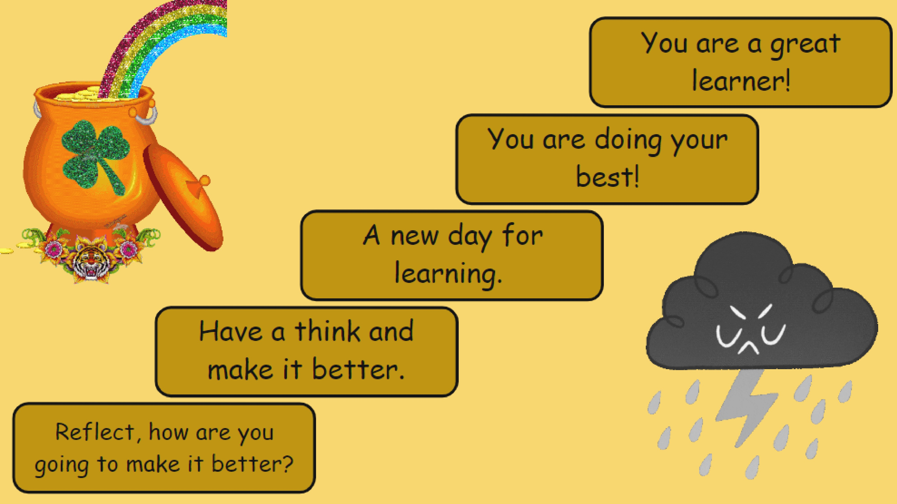
Behaviour chart
and house points




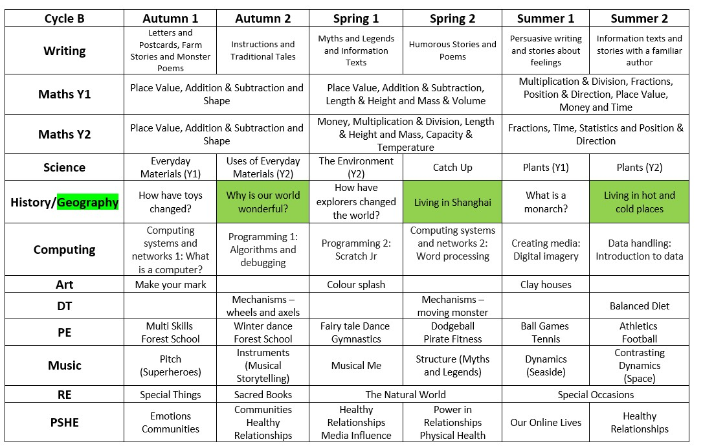

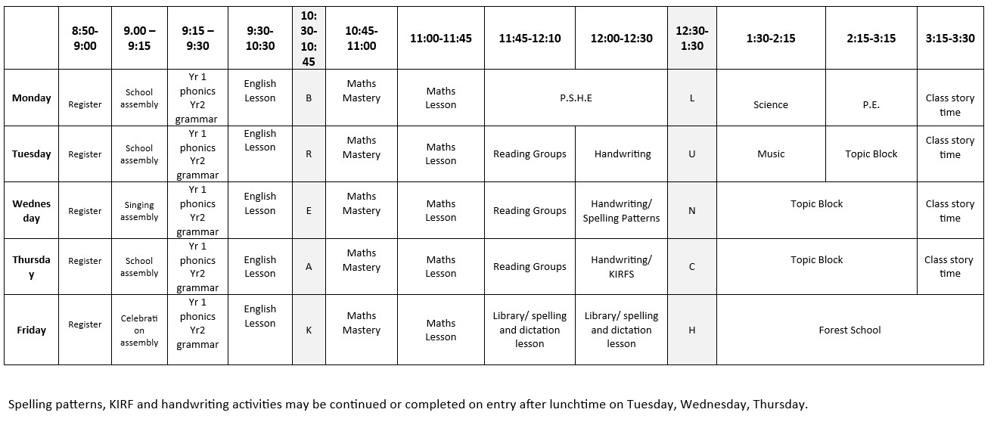
•
Forest School
–

Friday PM in the first half of autumn term.
Birch Class Timetable
-

Draft version: Subject to change

Staff in Birch Class
- Mrs Papacosta- Class Teacher for Year 1 and 2
- Mrs Huzaifa- Higher Level Teaching Assistant- She will alternate teaching Year 1 and 2 in the mornings and will teach the whole class for specific lessons.
- Mrs Shah- 1:1 Learning Support Assistant
- Mrs Ortega- 1:1 Learning Support Assistant
- Mrs Shepherd- Reading Group Assistant
Other adults that may support your child:
- Mrs Gonzalez and Mrs Malham run various interventions.
- Reading volunteers.

Phonics in
Year 1
•
Little Wandle Scheme
•
Daily lessons
•
Phonics feeds into daily reading and
spellings
•
Phonics Screening Check in Jun
e

•
You can access resources at:
Little Wandle Letters and Sounds > For

Parent
s

Little Wandle Phonics
Daily teaching and

same
day catch up
In Year 1, we begin
with a recap of Phase 3
sounds.
We move onto Phase 4
which is the blending
of initial sounds and
then Phase 5 sounds.
It builds up to blending
these sounds to make
words.
Common exception
words are taught
alongside this.
Assessed at the end of
each half term.

Homework
In line with our new policy, the expectations for work at home are as follows:
Reading: At least 5 times a week for 15+ minutes. Please ensure you note down what your child has read each day and that you have signed it. Reading forms the foundation of all learning which is why we have put a considerable focus on it as homework.
Maths Numbots: At least 5 times a week for 5 minutes per day.
Year 2 can continue to use their logins.
Year 1 will get their new logins soon and will have a go at logging on in class before we start setting it as homework.

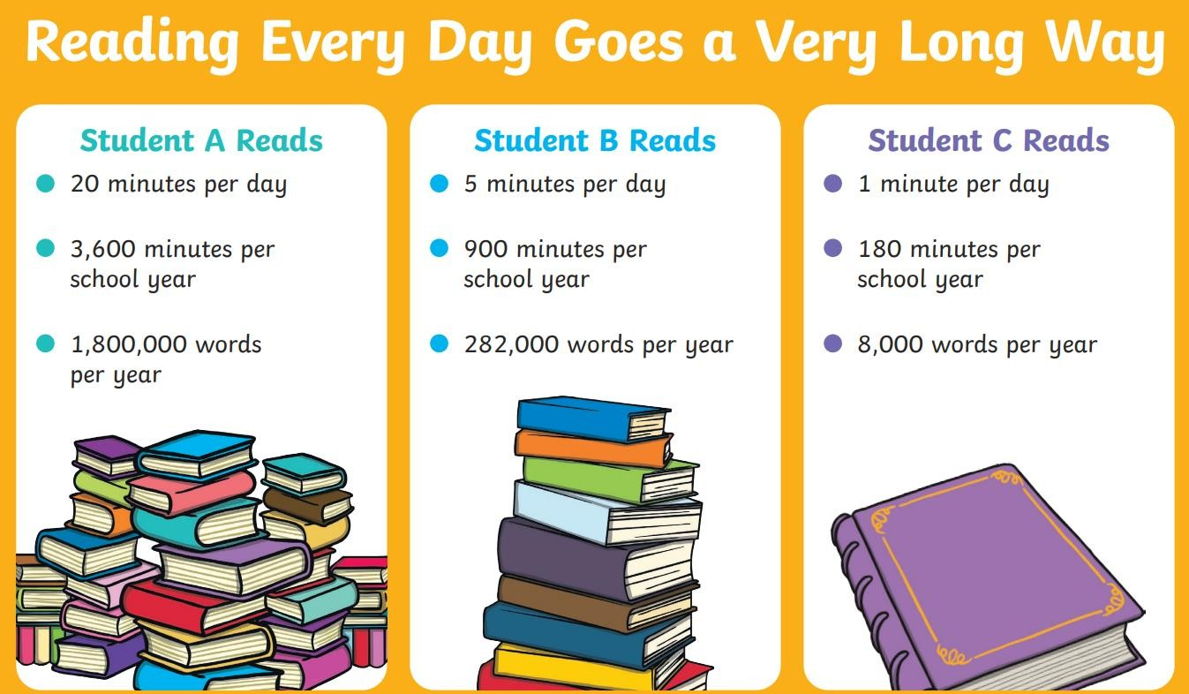

- Spelling has not been dropped.
- Teaching focuses on patterns, rules and word structure- little and often.
- Learning is embedded in writing and revisited frequently- e.g. dictation.
- Assessment is broader than a weekly test.
- The aim is transferable spelling knowledge for life-long writing.
We want our children to...
Spellings: No
test, no
problem
- be confident to transfer their spelling skills to different subject areas.
- retain their knowledge for longer. Ensure that spelling rules have shifted to long term memory.
Our sessions will be in line with the statutory spellings from the National Curriculum: https://assets.publishing.service.gov.uk/media/5a7c cc06ed915d63cc65ce61/English_Appendix_1_-_Spelling.pdf

Year 1 Reading books
Wednesday
•
All reading

books due in
.
Thursday
•
Little Wandle reading

book comes home
.
•
Extra supportive book comes home.
•
Library books due in
.
Friday
•
New Library book comes home.
All of the Year 1 children will read with an adult
at least 3 times a week on Tuesdays,
Wednesdays and Thursdays.
In Year 2, you may notice that some of the books your child brings home are banded:
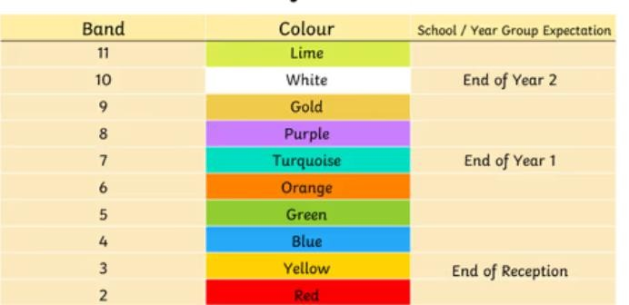
All Year 2 children will read with an adult at least 3 times a week on Tuesdays, Wednesdays and Thursdays.
They will be reading one book in school these reading sessions and they will bring one book home. The book will be changed as and when they finish it.
- Model positive reading behaviour
- Establish a routine so that reading takes place where it is quiet and without distraction
- Make reading an enjoyable experience
What if my child struggles with a book?
❖Allow time for your child to self-correct
❖Use positive language when correcting mistakes
❖Re-read pages to develop fluency, expression and comprehension
Reading At
Home
My child finds their book easy. What should I do to challenge them?
❖Discuss the pictures, characters and plot
❖Retell story in own words and suggest alternate endings
❖Focus on asking questions to allow the children to think beyond the story, share different genres and the purpose for reading them, encourage the learning of HFW and CEW.
❖Remember children should be reading the book at 90% fluency
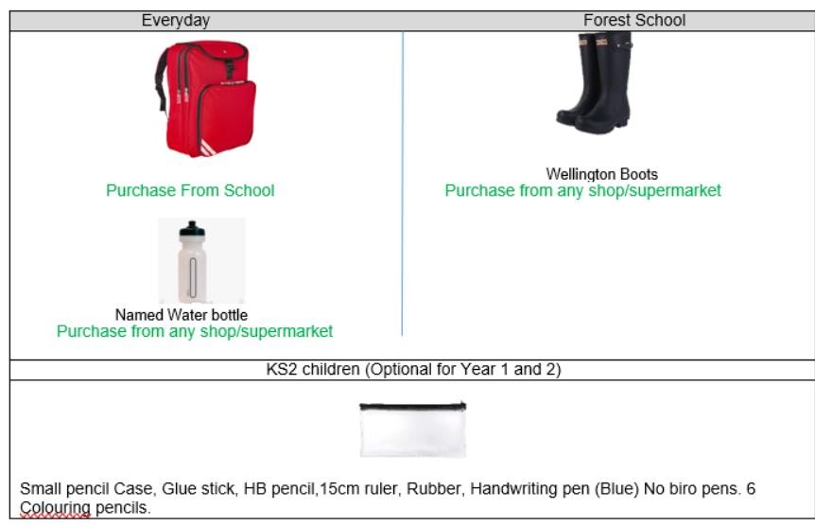

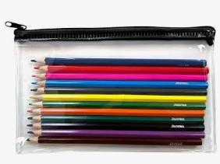
Uniform and Equipment
Optional but useful
-

a pencil case with colouring
pencils and pens, to be kept in their
bags but
used as and when needed.

Uniform
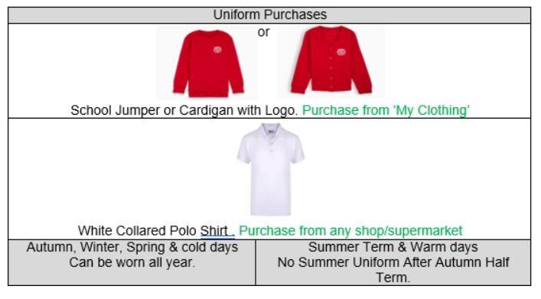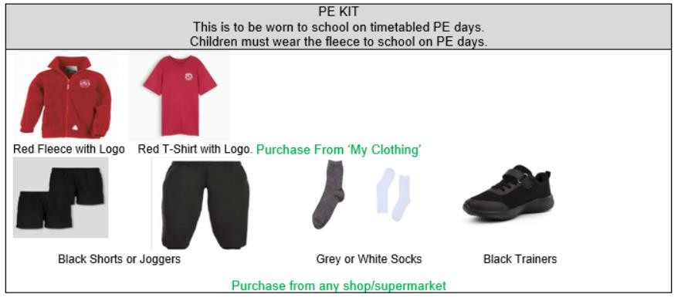
P.E. Days
Autumn 1 | Autumn 2 | Spring 1 | Spring 2 | Summer 1 | Summer 2
Monday | Monday Thursday | Monday Thursday | Monday | Monday Thursday | Monday Thursday
Some helpful reminders
Please send
Wellington

boots
for forest school.
Names in all items of clothing
and property.
PE is on a Monday.
Water bottles/snacks
Please ensure all uniform is in
line with the uniform policy.
Encourage general

Independence e.g. putting on
their coats and being able to
do them up, responsibility for
their own belongings.

